Correcting Data Formats

Definition
# Source: AI Source: Provided by: [Data Path: Persons Table -> ID Column: 1, Name_En Column: Motasem Essam] -> From: [Chatgpt (GPT‑5 Mini)] on [12/10/2025]
Correcting Data Formats is the process of standardizing the way data is represented in a dataset so that all values follow the same format.
- Different systems or users may store data in different formats, which can cause errors in analysis.
- Correcting formats ensures the data is consistent, accurate, and easy to process.
Key idea:
It is like making sure all dates, numbers, and text follow the same style so they can be easily understood and analyzed.

Characteristics
# Source: AI Source: Provided by: [Data Path: Persons Table -> ID Column: 1, Name_En Column: Motasem Essam] -> From: [Chatgpt (GPT‑5 Mini)] on [12/10/2025]
- Ensures uniform formatting of data values
- Applies to dates, numbers, text, and categorical data
- Helps avoid errors during sorting, filtering, and analysis
- Often performed during data preprocessing
- Can be done using spreadsheets, database tools, or scripts

Examples

1. Date Format Correction
# Source: AI Source: Provided by: [Data Path: Persons Table -> ID Column: 1, Name_En Column: Motasem Essam] -> From: [Chatgpt (GPT‑5 Mini)] on [12/10/2025]
Before cleaning:

Name | Date
Ali | 03/10/2026
Sara | 2026-03-10
Omar | 10-03-2026
After cleaning:

Name | Date
Ali | 2026-03-10
Sara | 2026-03-10
Omar | 2026-03-10
All dates now follow the same format (YYYY-MM-DD).

2. Text Format Standardization
# Source: AI Source: Provided by: [Data Path: Persons Table -> ID Column: 1, Name_En Column: Motasem Essam] -> From: [Chatgpt (GPT‑5 Mini)] on [12/10/2025]
Before cleaning:
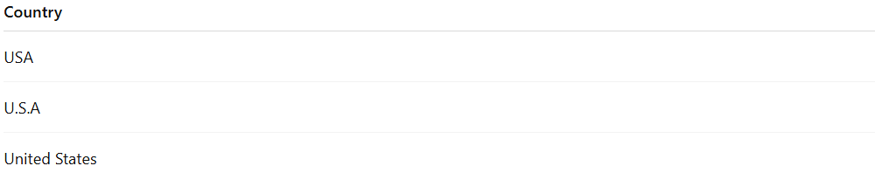

Country
USA
U.S.A
United States
After cleaning:

Country
USA
USA
USA
The country name is standardized to one consistent value.

3. Number Format Correction
# Source: AI Source: Provided by: [Data Path: Persons Table -> ID Column: 1, Name_En Column: Motasem Essam] -> From: [Chatgpt (GPT‑5 Mini)] on [12/10/2025]
Before cleaning:
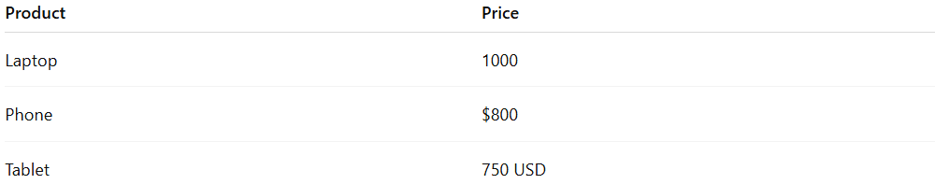
Product | Price
Laptop | 1000
Phone | $800
Tablet | 750 USD
After cleaning:
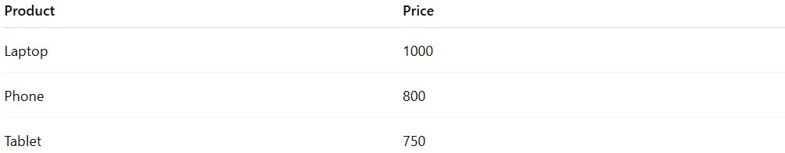
Product | Price
Laptop | 1000
Phone | 800
Tablet | 750
All prices now use the same numeric format.

Example Section
# Source: AI Source: Provided by: [Data Path: Persons Table -> ID Column: 1, Name_En Column: Motasem Essam] -> From: [Chatgpt (GPT‑5 Mini)] on [12/10/2025]
A company stores sales dates in different formats.
Before cleaning:

Order ID | Order Date
101 | 03/10/2026
102 | 2026-03-10
103 | 10 Mar 2026
Cleaning process:
- Convert all dates into a single standard format.
After cleaning:
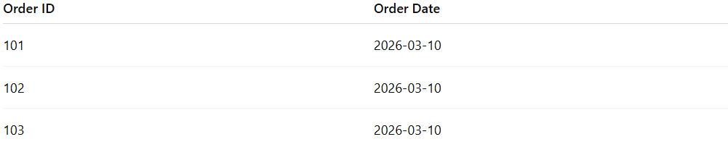
Order ID | Order Date
101 | 2026-03-10
102 | 2026-03-10
103 | 2026-03-10
This ensures consistent data formatting for accurate sorting and analysis.

Advantages
# Source: AI Source: Provided by: [Data Path: Persons Table -> ID Column: 1, Name_En Column: Motasem Essam] -> From: [Chatgpt (GPT‑5 Mini)] on [12/10/2025]
- Improves data consistency and readability
- Prevents errors during analysis or calculations
- Makes data easier to sort, filter, and compare
- Ensures compatibility with databases and analytical tools

Disadvantages
# Source: AI Source: Provided by: [Data Path: Persons Table -> ID Column: 1, Name_En Column: Motasem Essam] -> From: [Chatgpt (GPT‑5 Mini)] on [12/10/2025]
- Can be time-consuming for large datasets
- Incorrect formatting rules may alter original data meaning
- Requires careful verification after conversion
- Some formats may lose detail during standardization

